

**Web Technology Final Project**

Topic: Rwanda Tour management

Names: Muranga Ruth

ID:24430

1. **Purpose of the project**

The purpose of the Rwanda Tour Management System is to establish a web-based platform designed to efficiently manage the operations of a tour management business within Rwanda. The system aims to streamline the tour planning and booking processes, elevate the overall customer experience, and optimize the management of tour resources and itineraries. The primary goal is to enhance the effectiveness and organization of tour-related operations, facilitating seamless coordination between tour providers and clients while promoting the beauty and cultural richness of Rwanda as a preferred tourist destination.

1. **Requirements:**

* User Management:

I. Implementation of registration and login functionality for both customers and administrators.

II. Establishment of user roles and permissions to differentiate between customer and administrator access levels.

III. Provision for customers to modify and update their user profiles.

**Tour Inventory Management:**

* Capability to add, update, and delete tour details, including destination, itinerary, duration, availability, and pricing.
* Implementation of search and filtering options, enabling customers to find available tours based on criteria such as destination and duration.

**Reservation Management**:

* I. Functionality allowing customers to make reservations for specific tours, selecting preferred dates and package options.

**Admin Dashboard**:

1. I. Development of an intuitive and secure administration panel for efficient management of tours, reservations, and users.
2. II. Notification system to inform clients about the approval status of their tour reservations.

**User-Friendly Interfaces:**

I. Creation of responsive and user-friendly interfaces tailored for both customers and administrators.

II. Implementation of easy navigation and clear instructions to enhance the user experience and facilitate task completion.

**Expected Outcomes:**

I. Streamlined Tour Inventory Management: The system should facilitate easy addition, modification, and deletion of tour details. Search and filtering options should assist customers in finding suitable tours based on preferences.

II. Seamless Reservation Process: The system should provide customers with a straightforward process to make reservations for specific tours and dates.

**Specific Constraints**:

I.Technology: The system should be developed using the Spring Boot framework, ensuring compatibility with Java-based technologies and databases commonly used in tour management.

II.Security: Priority should be given to securing user data, ensuring robust authentication, and authorization mechanisms to protect personal information.

1. Scalability: The system architecture should be designed for scalability, accommodating future growth in the number of tours, customers, and reservations.

**Limitations:**

I. System Performance: The system's performance may be influenced by factors such as server capabilities, network infrastructure, and database performance.

II. Customization and Extensibility: While the system meets common requirements, adding new features or functionalities not initially considered may require additional development efforts.

III. Manual Payment Handling: The system is limited to manual payment handling; users may be required to make payments outside the system.

**User Documentation:**

**I.** First once user load the application he view Welcome 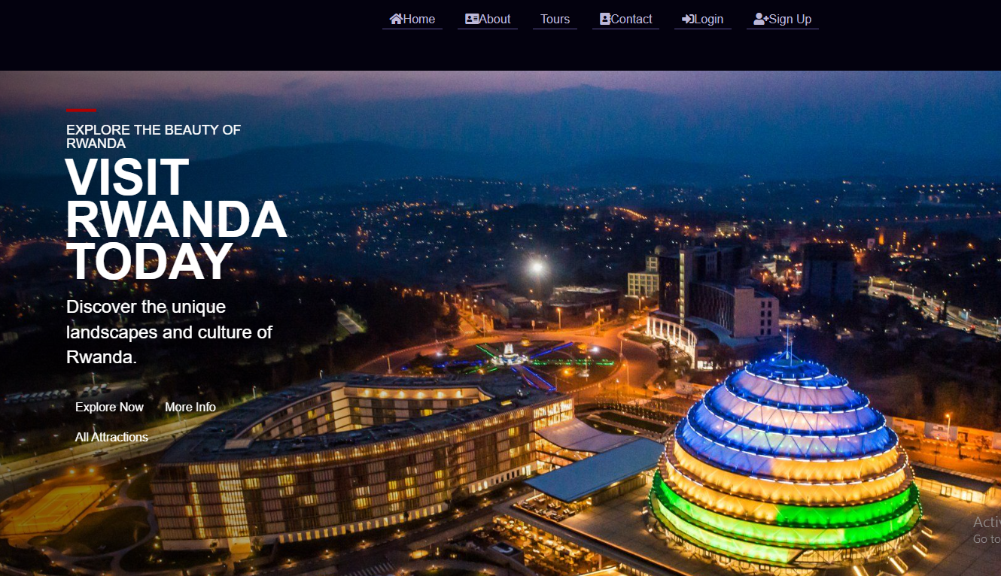

This is about the system the view for the customer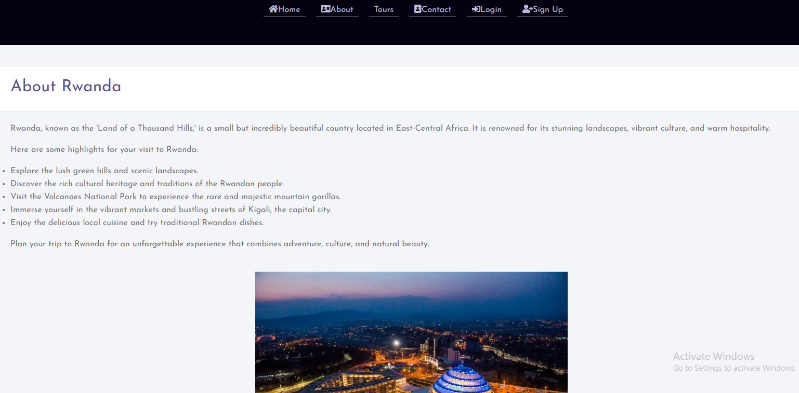

This is how my database designed

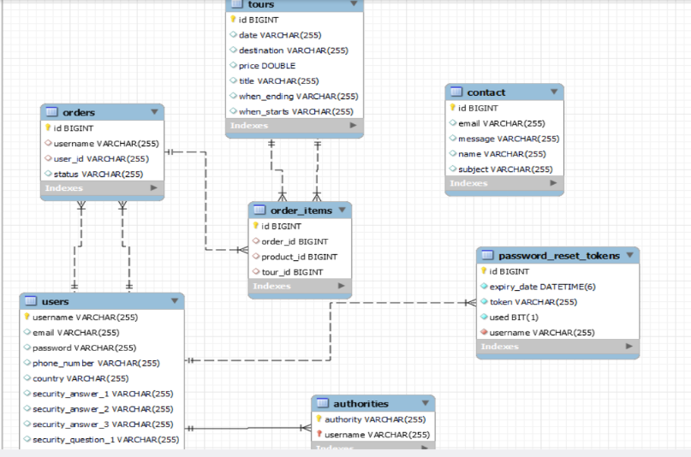

II. For the new user to Enter in the system need to make Registration after then Login

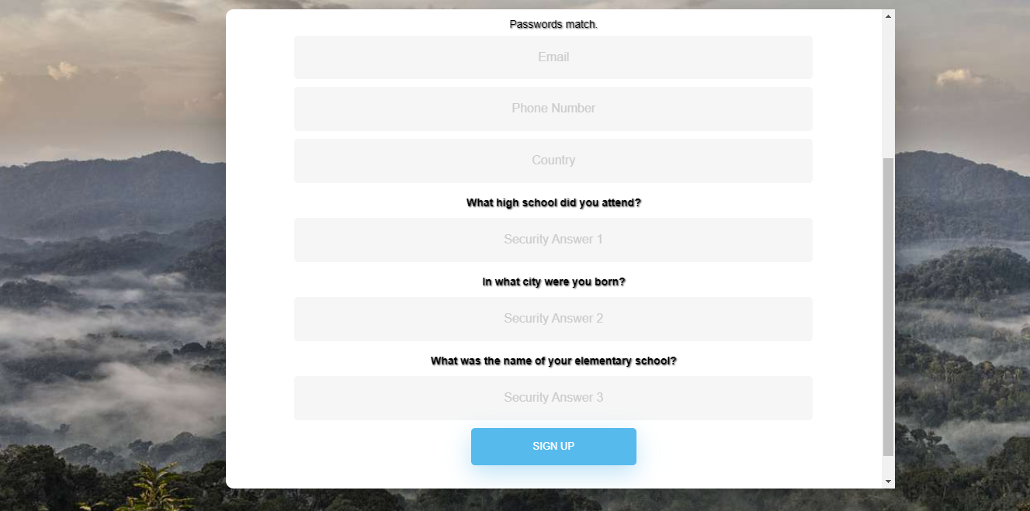

On Login page, user should Enter the username and password entered during registration otherwise the system will not allow him to continue. For this tutorial let use .

**Username: muranga; password :12345 but you can also create new user and log in using its credentials**

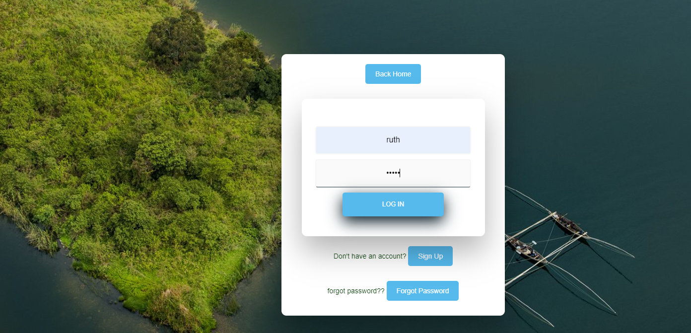

When login successfully user will direct to his or her account where he can perform make thing like booking, view booked tour and account details, search also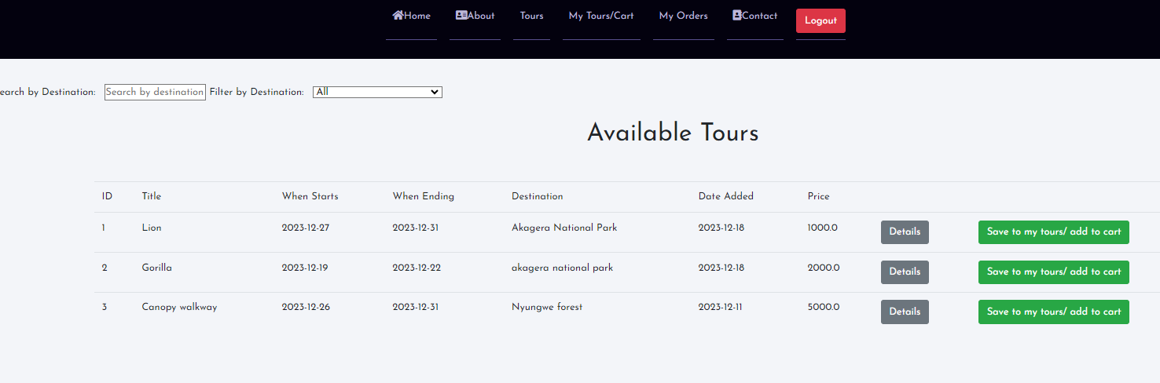

When user want to order tour, click on create order button then After clicking , he /she will receive the email for order confermation.



After making order the client can be able to see the details of his or her order

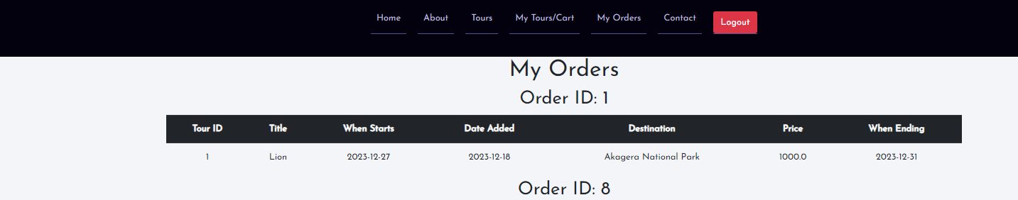

The user can also be able to contact to the admin

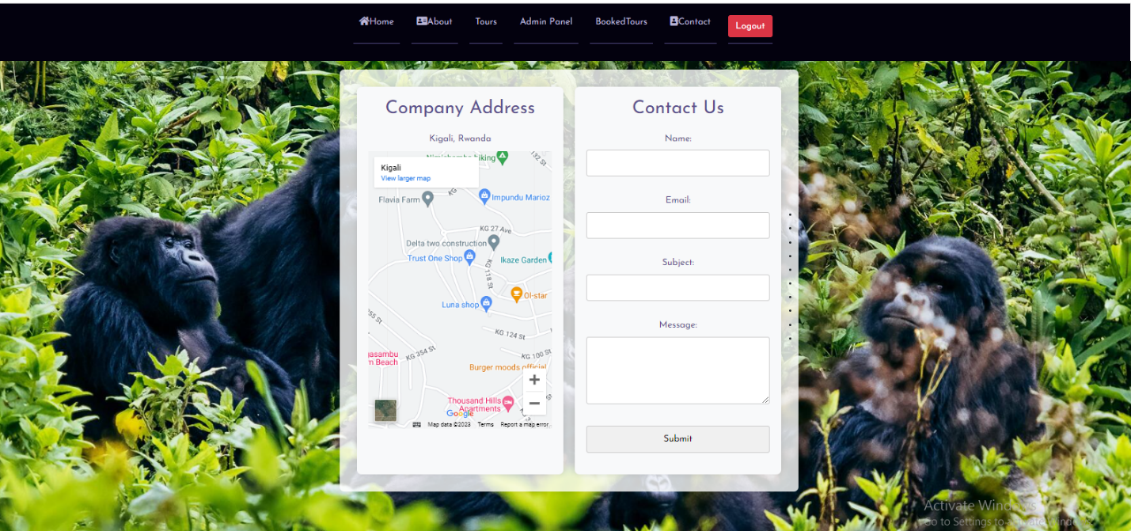

For Admin Account the Administrator must login as admin by providing the username and password by using this credentials ;**username:ruth,passward:admin@123**

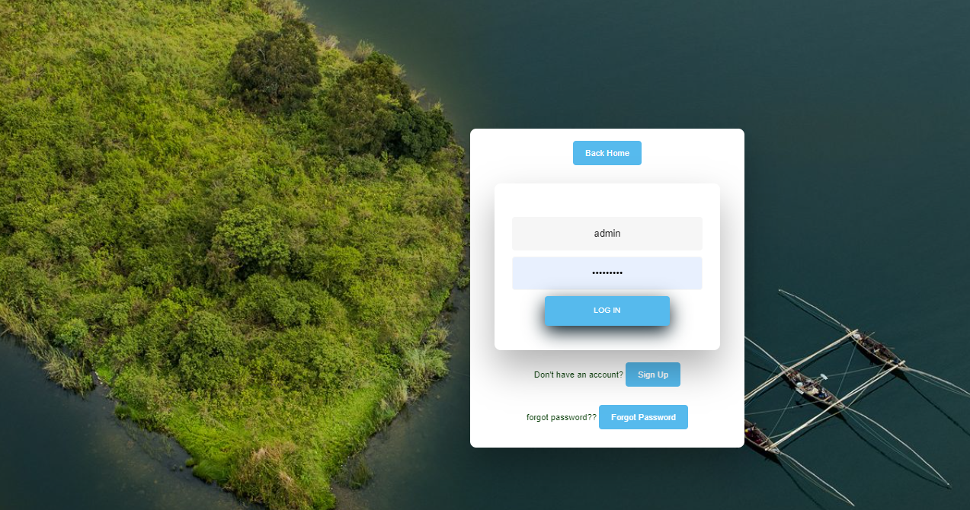

Here the admin can view all the information the client made

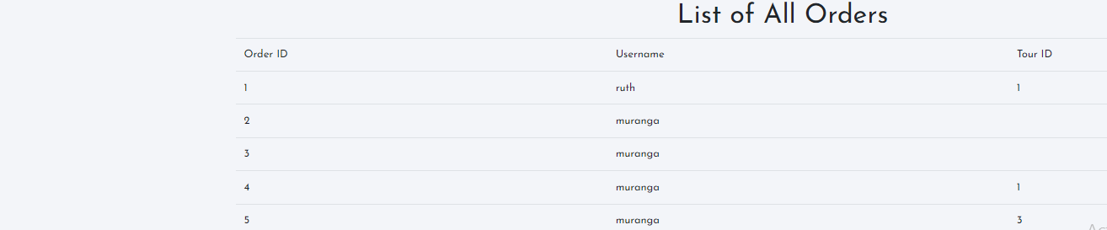

Admin can approve or reject the booked request and the system will Automatically sending the email to the customer.



The admin may also be able to search ,delete ,update the tour also filtet by destination.

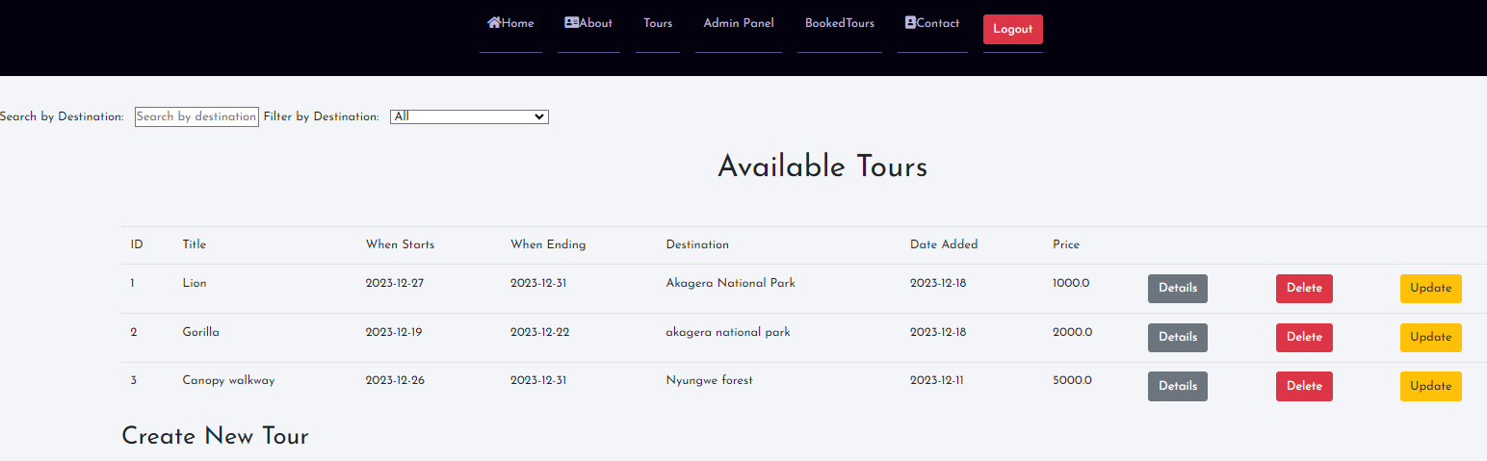

Admin can also view the booked order tour and download the pdf document

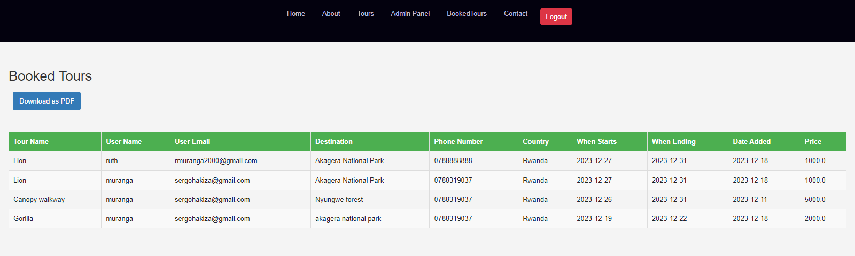

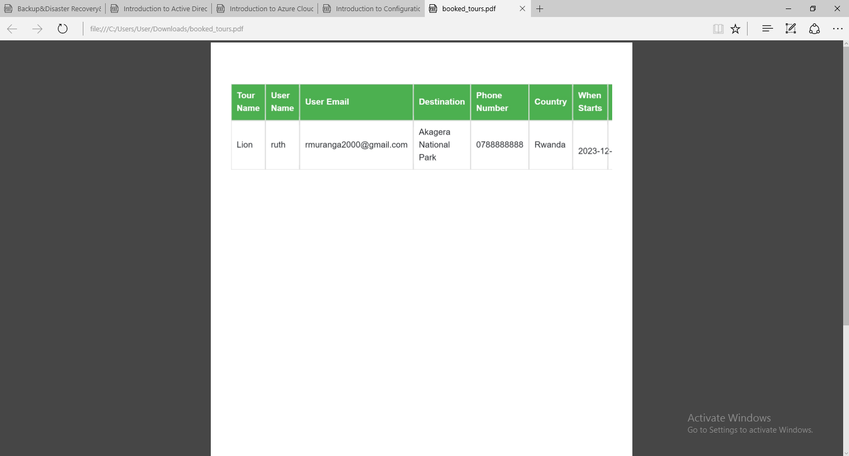

Technical Documentation:

Rwanda Tour Management System

* Architecture Overview:

The Rwanda Tour Management System is developed using the Spring Boot framework, employing a layered architecture pattern. The system encompasses the following layers:

a. Presentation Layer: This layer manages user interaction and presents the user interfaces. It includes controllers responsible for handling HTTP requests and rendering appropriate responses.

b. Service Layer: The service layer encapsulates the business logic of the application. It serves as an intermediary between the presentation and data access layers, implementing core functionalities.

c. Data Access Layer: Interacting with the database and managing data persistence is the responsibility of this layer. It incorporates repositories or DAOs (Data Access Objects) for querying and manipulating data.

d. Database: The system utilizes a relational database management system (RDBMS), specifically MySQL, for efficient data storage.

Implementation Details: The Rwanda Tour Management System is implemented using the Java programming language along with the Spring Boot framework. Key implementation details include:

* User Management:

User registration and login functionalities for both customers and administrators.

User roles and permissions to differentiate between customers and administrators.

Allowing customers to change their profile information.

* Tour Inventory Management:

Ability to add, update, and delete tour details, such as destinations, itineraries, durations, availability, and pricing.

Search and filtering options for customers to find available tours based on specific criteria.

* Reservation Management:

Allowing customers to make reservations for specific tours and dates.

* Admin Dashboard:

Intuitive and secure administration panel for managing tours, reservations, and users.

Notification feature to inform clients about the approval or rejection status of their reservation requests.

* User-Friendly Interfaces:

Responsive and intuitive interfaces for customers and administrators.

Easy navigation with clear instructions for performing tasks.

Technical Stack:

* Framework:
* Spring Boot
* Programming Language:

Java

Database: MySQL (RDBMS)

* Security Measures:

Secure authentication and authorization mechanisms to protect user data and ensure privacy.

Scalability:

Designed to handle a growing number of tours, customers, and reservations, ensuring scalability for future expansion.

* Documentation:

Comprehensive technical documentation, including installation instructions, user manuals, and developer guides.

Limitations:

* System Performance:

Performance may be influenced by factors such as server capabilities, network infrastructure, and database performance.

* Customization and Extensibility:

Limited customization and extensibility; adding new features may require additional development efforts.

* Manual Payment Handling:

The system is limited to manual payment processing; users are required to make payments outside the system.

* 1. **Spring Boot:** The system leverages the Spring Boot framework for rapid application development and to simplify configuration and deployment.
  2. **Spring MVC:** Spring MVC (Model-View-Controller) is used to handle the presentation layer and manage the flow of requests and responses.
  3. **Spring Data JPA:** Spring Data JPA is used to simplify the implementation of the data access layer. It provides abstractions and automatic CRUD (Create, Read, Update, Delete) operations for interacting with the database.
  4. **Hibernate:** Hibernate is used as an Object-Relational Mapping (ORM) tool to facilitate the mapping between Java objects and the underlying database tables.
  5. Security: Spring Security is utilized for implementing authentication and authorization mechanisms, ensuring secure access to the system's resources.
  6. Dependency Management: Maven or Gradle is used for managing project dependencies and building the application.

**Additional Technical Details:**

Here are some additional technical details relevant to the Rwanda tour Management System:

* 1. Server-Side Technologies: The system runs on a Java Servlet container such as Apache Tomcat.
  2. Front-End Technologies: The user interfaces are built using HTML, CSS, thymeleaf and JavaScript frameworks.

e. Deployment: The system can be deployed on various platforms for source code is on github and hosted on Heroku.